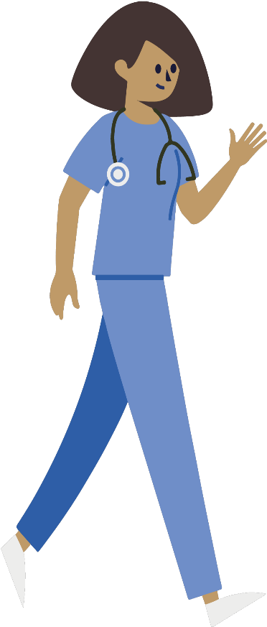
Information on COVID-19

What is COVID-19?
COVID-19 is an infectious disease, caused by a newly discovered coronavirus strain that first emerged in China in December 2019.
In humans, several coronaviruses are known to cause respiratory infections ranging from the common cols to more severe disease.
The new coronavirus outbreak (COVID-19) was declared a pandemic by the World Health Organization on 11 March 2020.

The most important symptoms of COVID-19 are recent onset of any of the following:
- a new continuous cough
- a high temperature
- loss of, or change to your sense of smell or taste.
For most people, COVID-19 will be a mild illness. However, if you have any of the symptoms listed you should self-isolate at home.

After your visit to A&E or GP

You have been identified as having symptoms of COVID-19 infection
You need to go home and self-isolate for seven days from the onset of your symptoms. If you live with others, they need to isolate for 14 days from the onset of your illness. If anyone else in the household starts displaying symptoms, they need to stay at home for seven days from when the symptoms appeared, regardless of what day they area on in the original 14-day isolation period.

What happens once I leave hospital?
At this point you are considered well enough to leave hospital. You will have been prescribed medication if required. If you did not require any prescribed medication, then you should be able to manage your symptoms yourself at home.
Ensure you stay hydrated and take paracetamol if you have a temperature. To aid recovery, try to avoid spending long periods of time lying flat in bed; try sitting up or in a chair, or moving around at home.
You may have a cough or feel tired or breathless for several weeks, despite the COVID-19 having cleared. However, if the symptoms persist, please

call your GP for a review. If you are still struggling to manage your symptoms at home, or your condition gets worse, please contact:
_ _ _ _ _ _ _ _ _ _ _ _ _ _ _ _ _ _ _ _ _ _ _ _ _ _ _ _
_ _ _ _ _ _ _ _ _ _ _ _ _ _ _ _ _ _ _ _ _ _ _ _ _ _ _ _
Your care team may wish to give you some specific guidance below:
_ _ _ _ _ _ _ _ _ _ _ _ _ _ _ _ _ _ _ _ _ _ _ _ _ _ _ _
_ _ _ _ _ _ _ _ _ _ _ _ _ _ _ _ _ _ _ _ _ _ _ _ _ _ _ _
_ _ _ _ _ _ _ _ _ _ _ _ _ _ _ _ _ _ _ _ _ _ _ _ _ _ _ _
_ _ _ _ _ _ _ _ _ _ _ _ _ _ _ _ _ _ _ _ _ _ _ _ _ _ _ _
For a medical emergency, dial 999 immediately

When you get home

Can I spread COVID-19 to friends and family?
There is a risk that members of your household – or others you have been in close contact with over the past two weeks – have been exposed to the virus, but it is possible that they have not. Therefore, you should follow the government’s isolation guidance: https://www.gov.uk/government/publications/covid-19-stay-at-home-guidance/stay-at-home-guidance-for-households-with-possible-coronavirus-covid-19-infection
Please continue to monitor this guidance, as it is updated regularly as more evidence becomes available. This will ensure you have the most up to date information on when it is safe to end your self-isolation (and household isolation, if you live with others).
Please note that a persistent cough alone does not mean someone must continue to self-isolate beyond the duration advised by the government.

Can I get COVID-19 again?
You probably have some immunity to COVID-19 but it’s not clear how long it will last. You must self-isolate again if someone you live with (or someone in your support bubble) gets symptoms. You must self-isolate again even if you’ve had a positive test result for COVID-19 before.
Do I need to wear a facemask?
You may be issued with a mask to wear as you travel home. Find the latest guidance regarding facemasks here: https://www.gov.uk/government/publications/staying-safe-outside-your-home
What if I feel unwell again?
Monitor your symptoms regularly and if you have any concerns, go to: https://www.nhs.uk/conditions/coronavirus-covid-19/check-if-you-have-coronavirus-symptoms/

Protecting yourself and others from COVID-19

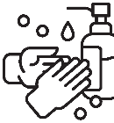  Wash your hands frequently and thoroughly, for at least 20 seconds. Use alcohol-based sanitiser if soap and water aren’t available. | 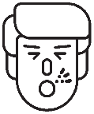  Cover your mouth and nose with a tissue when you cough or sneeze, and then throw the tissue in the bin and wash your hands. Alternatively, cough or sneeze into your elbow. | Avoid touching your eyes, nose and mouth with unwashed hands. | 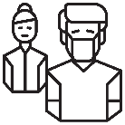  Avoid close contact with people who are sick, sneezing or coughing

