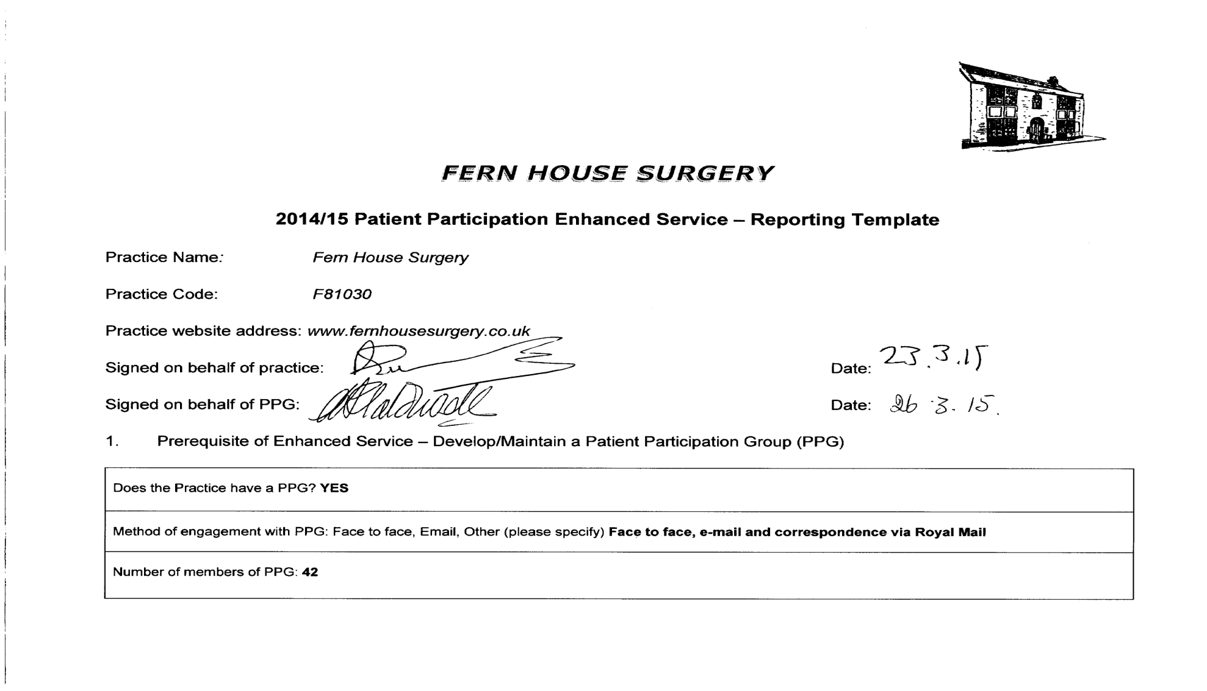

Detail the gender mix of practice population and PPG:  No. of Patients Male Female  Practice 7759 8287  PRG (%) 12% 30% | Detail of age mix of practice population and PPG:  No. of Patients <16 17-24 25-34 35-44 45-54 55-64 65-74 > 75  Practice 3117 1370 1802 2166 2305 1852 1907 1527  PRG 0.14% 0.1% 0.36% 0.30% 0.59% 0.47% 0.19%

Detail the ethnic background of your practice population and PRG:

No. of Patients | White |  |  |  | Mixed/ multiple ethnic groups
 | British | Irish | Gypsy or Irish traveller | Other white | White &black Caribbean | White &black African | White & Asian | Other mixed
Practice | 11900 | 87 | 0 | 465 | 78 | 73 | 51 | 44
PRG (%) | 0.31% |  |  | 0.21% |  | 4.1% |  | 2.27%

No. of Patients | Asian/Asian British |  |  |  |  | Black/African/Caribbean/Black British |  |  | Other
 | Indian | Pakistani | Bangladeshi | Chinese | Other  Asian | African | Caribbean | Other Black | Arab | Any other
Practice | 47 | 17 | 20 | 55 | 80 | 27 | 14 | 20 |  | 3068
PRG (%) |  |  |  |  |  |  |  | 5%

Describe steps taken to ensure that the PPG is representative of the practice population in terms of gender, age and ethnic background and other members of the practice population:

Whilst the members of our PPG tends to lean towards the female population, it was recognised, that to be more reflective of our practice profile, the group needed more representation from the younger age group <16 to 24, as well as from the multi-ethnic backgrounds that make up our patient list. Despite extensive advertising including posters, networking and our Practice Leaflet, we have not yet achieved a group that is a representative of our practice population as we would wish. Further steps will be pursued in order to hopefully achieve a more balanced profile, through the engagement with those groups under represented. In addition to our existing PPG member, 4 members have left the Practice and we also have a further seven patients, who have indicated their willingness to be involved with reviewing survey analyses and participating in the formation of action plans and decision making.

Are there any specific characteristics of your practice population which means that other groups should be included in the PPG?
e.g. a large student population, significant number of jobseekers, large numbers of nursing homes, or a LGBT community?
NO

If you have answered yes, please outline measures taken to include those specific groups and whether those measures were successful:

- Review of patient feedback

Outline the sources of feedback that were reviewed during the year:

NHS Patient Choices website
Written and Verbal Complaints received
Friends and Family Test (from December 2014 onwards)
Annual Patient Participation Group Meeting
Meetings between PPG Lead and Practice Manager
IWantGreatCare (https://www.iwantgreatcare.org)

How frequently were these reviewed with the PRG?

- Annual PPG Meeting
- The Practice communicates regularly with the PPG Lead
- Information sent to PPG Members by e-mail or cascaded via Royal Mail

- Action plan priority areas and implementation

Priority area 1
Description of priority area:

Non-attendance at appointments.

Non-attendance at appointments continues to be a problem. PPG members suggested that the current poster detailing this could be presented as a positive rather than a negative. This would offer the opportunity to educate patients regarding the total number of appointments GPs provide.

Other ideas included improving the answer phone message so that cancelling appointments would be easier and developing a system of escalating contacts (friendly call to formal letter) with those who do not attend.
What actions were taken to address the priority?

- Asking patients who booked over the phone to repeat back the time and date of their appointments and encourage patients to use the e-mail facility to cancel appointments.
- Text messaging system is now in place, confirming and reminding patients their appointment times.
- Changing existing posters stating how many patients had attended their appointments in the previous month.
- More posters displayed in waiting room encouraging patients to use the e-mail facility to cancel appointments
- Practice Website updated outlining the constant concern that some patients are making appointments and then don't attend. Patients who do not attend booked appointments will be blocking appointments for other patients, which ultimately can increase inappropriate and unnecessary A&E attendance.
- Patients are randomly called if they miss an appointment to establish the reason for failing to attend.

Result of actions and impact on patients and carers (including how publicised):
Throughout the month of February 2015, some patients were called to establish why they failed to attend their appointment. While there were many reasons for patients failing to attend appointments - including feeling better, transportation problems or being unable to get through to the surgery to cancel - the most common reason was that they simply forget. Due to the change of clinical system, the Practice now has the facility to offer online access for patients to book, cancel and amend appointments. The Practice is hoping the increase in the number of patients, booking, cancelling and amending appointments on-line, will reduce the number of patients who do not turn up for their appointment.
Impact on patients and carers: It is too early to see any major impact as this action point will be on-going for the foreseeable future.
Publicised: Posters and Website

Priority area 2
Description of priority area:

Increasing population demands

Concerns regarding the increasing population demands and the ability to limit addition of new patients joining Fern House Surgery

What actions were taken to address the priority?

- The Practice is currently in the process of applying to NHS England to close the Practice list.
- The Practice advertised for full time GPs and employed locums to try and meet demands.
- The Practice advertised for a full time Nurse Prescriber.
- Discussions taken place with neighboring Practices and PPG Lead.

Result of actions and impact on patients and carers (including how publicised):

- Discussions have taken place between the three other Practices in the area, resulting in one Practice happy for Fern House to suggest patients register at their Practice. All three Practices do not have any objections to Fern House closing their patient list.
- The Practice recruited one GP and will continue to advertise for a full time GP and employ locums
- The Practice will continue to advertise for a full time Nurse Prescriber and if unsuccessful the Practice will look to recruit a locum Nurse.

Impact on patients and carers: The continuing rise of the population in Witham, has a knock on effect for the increase demand for appointments, patients are experiencing extreme difficulties getting through to the Practice via the telephone system to book appointments.

Publicised: The Practice will keep patients updated via the Website and display posters in the Surgery.

Priority area 3
Description of priority area:

Patients often do not know the best times or methods of contacting the surgery – i.e. to obtain test results

What actions were taken to address the priority?

- Reviewed Practice booklet, website and recorded telephone message.
- Liaised with each department in the Practice to gain their views.
- Notices/posters placed in more prominent positions.

Result of actions and impact on patients and carers (including how publicised):

- The Practice will be changing the times patients can obtain test results to improve telephone access.
- Recorded telephone message, website, Practice booklet and notices will be updated accordingly to reflect changes.
Impact on patients and carers: With on-line services now available, patients will be encouraged to use this facility instead or telephoning the Practice. It is too early to see any major impact as this action point will be on-going for the foreseeable future.

Publicised: Practice booklet, website, recorded telephone message and notices/posters.

Progress on previous years

If you have participated in this scheme for more than one year, outline progress made on issues raised in the previous year(s):

Action Plan 2012 / 2013

Issues | What we did | The Results
Speaking to a doctor/nurse by telephone | The Practice Nurse has additional telephone consultations between the hours of 12:00pm to 12:30pm and 3:00pm to 3:30pm. Reception staff also take messages and pass these on to the Practice Nurses. | This has eased the pressure on incoming telephone calls first thing in the morning.
Seeing a doctor of choice | The Practice created additional 48 and 72 hour appointments and extended the appointment book by a further 2 weeks | Satisfaction from the Survey went from 54% (2013) to 78% (2014)
Condition of waiting areas | The Practice had the chairs recovered meeting infection control requirements. This is still on-going | Satisfaction from the Survey went from 63% (2013) to 84% (2014)

Action Plan 2013 / 2014

Issues | What we did | The Results
On-line Appointments | This facility is now available for patients. | It is too early to see any major impact as this action point will be on-going for the foreseeable future.
Review use of car park to create a Parent and Child Parking Space | The use of the car park was reviewed. | A parent and child space was created next to the disabled parking.
Possibilities for extended opening hours | Due to current Clinical Staff shortages this action point has been deferred.

- PPG Sign Off

Report signed off by PPG: YES

Date of sign off: 26.03.15

How has the practice engaged with the PPG: Through meetings/telephone conversations, email communication and regular contact with the PPG Lead.

How has the practice made efforts to engage with seldom heard groups in the practice population?

The Practice has compared the demographics of its patient participation group to that of its practice population and found that the relatively young and patients without long term conditions, ethnic minorities and under 35’s are still under- represented.
The Practice is still considering further action to rectify this to ensure that the patient participation group is representative of its registered patients and needs to raise awareness further by advertising the group more frequently on the Practice website
and posters in the Practice, in an attempt to recruit new members. The Practice will be specifically advertising for new members from categories of patients currently under-represented in this way this coming year. All new patients registering with the Practice if appropriate are asked to join the PPG.

Has the practice received patient and carer feedback from a variety of sources?
Yes, Friends and Family, verbal feedback, feedback direct from carers, complaints and NHS choices.

Was the PPG involved in the agreement of priority areas and the resulting action plan?
Yes, Priority areas were agreed at PPG meeting and resulting action plan was sent to all members.

How has the service offered to patients and carers improved as a result of the implementation of the action plan?

Improvements have been made to the appointment and prescription systems, to the website and other forms of Practice-patient
communications.

Do you have any other comments about the PPG or practice in relation to this area of work?

We hope to do more work in raising awareness about dementia. In addition, to also improving telephone and appointment systems the Practice Manager will lead in planning this, but will work jointly with the PPG in the months ahead.

